OBJECT ORIENTED PROGRAMMING
When getting ready for a software engineering interview, remember that in addition to being familiar with the specific technology related to the job, you should also be well-versed in fundamental Object-Oriented Programming concepts.
Object oriented programming:
Object-Oriented Programming (OOP) is a programming paradigm centered around the concept of objects, which bundle data and methods to model real-world entities and their interactions.
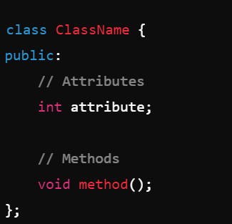
Class:
A blueprint for creating objects that encapsulates data (attributes) and functions (methods) to operate on the data. The class does not consume memory at runtime.
Object:

An object is a concrete instance of a class. While a class defines the structure and behavior (data and methods) that objects created from it will have, an object is a specific realization of that class, containing actual values and state.
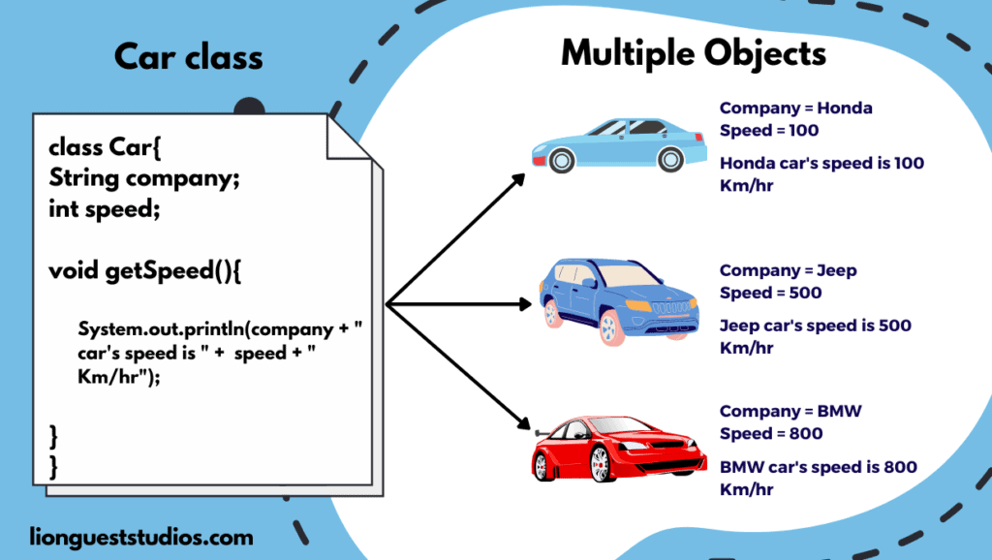

Constructor:
A constructor is a special member function in a class used to initialize objects of that class. It is called automatically when an object is created and is responsible for setting up the initial state of the object.
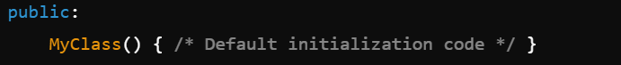
Default constructor:

Parameterized constructor:
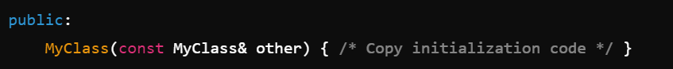
Copy constructor:

Move constructor: (C++11 and later)

Access modifiers:
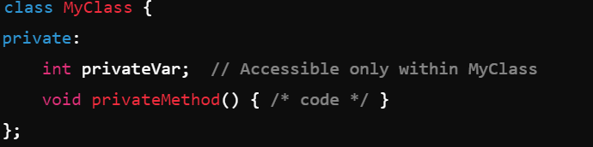
Access modifiers in Object-Oriented Programming (OOP) are keywords used to specify the accessibility or visibility of class members (attributes and methods) from outside the class.
- Public: Used for methods and attributes that need to be accessed from outside the class.

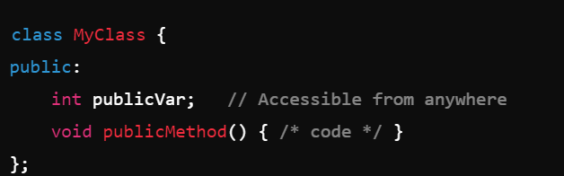
- Private: Used for data members and methods that should be hidden from other classes and functions to prevent unintended interference.

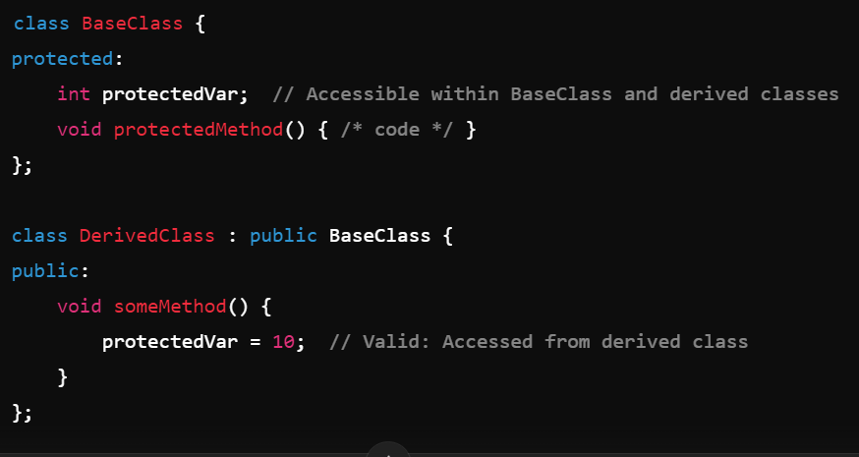
- Protected: Used to allow derived classes to access and modify certain members while still keeping the hidden from non-derived classes.

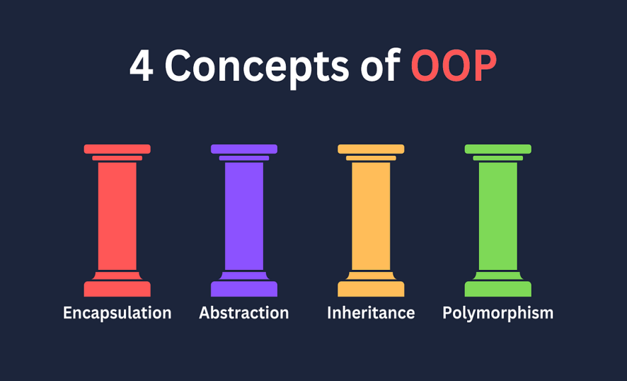
Main principles of OOPs:

- Encapsulation
- Abstraction
- Inheritance
- polymorphism

Encapsulation:
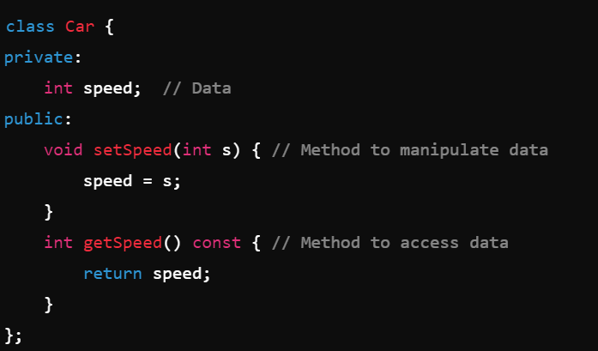
Involves bundling data and methods within a class, and controlling access to the data through access modifiers. It promotes data hiding, enhances security, and improves maintainability and flexibility in code. It involves restricting direct access to some of the object's components, which is intended to prevent unintended interference and misuse of the object's internal state. The data and the operations that manipulate the data are contained within the same structure, creating a cohesive unit.
Key Points of Encapsulation
Data Hiding: Restricts direct access to an object's internal state, exposing only what is necessary through public methods.
Access Modifiers: Uses keywords like private, protected, and public to control visibility and access to class members.
Getter and Setter Methods: Provides controlled access to private data members, allowing validation and encapsulation of logic.
Improved Security: Protects object integrity by preventing unintended interference and misuse of data.
Modularity: Promotes separation of concerns, making the code base easier to manage and understand.
Maintainability: Simplifies modifications by isolating changes to a specific class without affecting other parts of the program.
Abstraction:
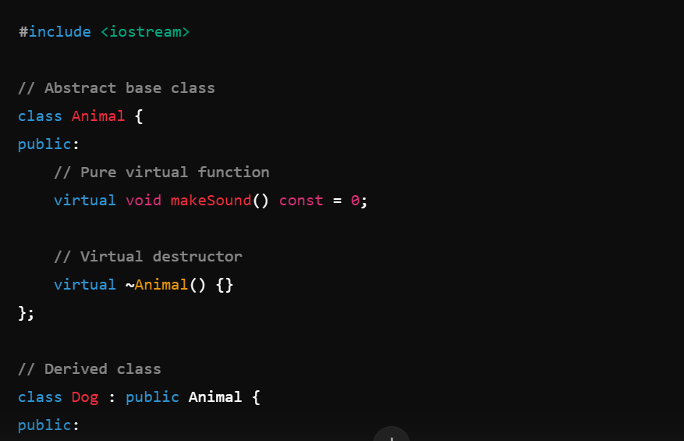
Helps manage complexity by hiding the detailed implementation of objects and exposing only the essential features that are relevant for interaction.
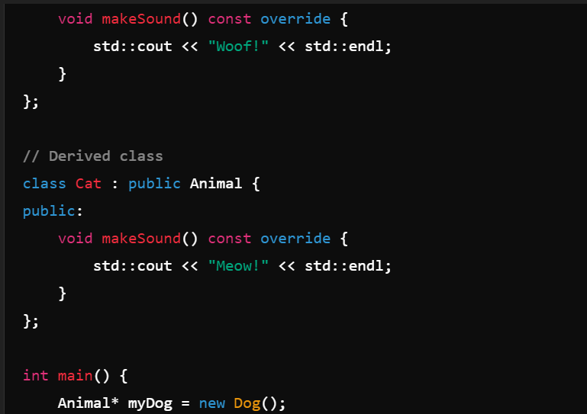
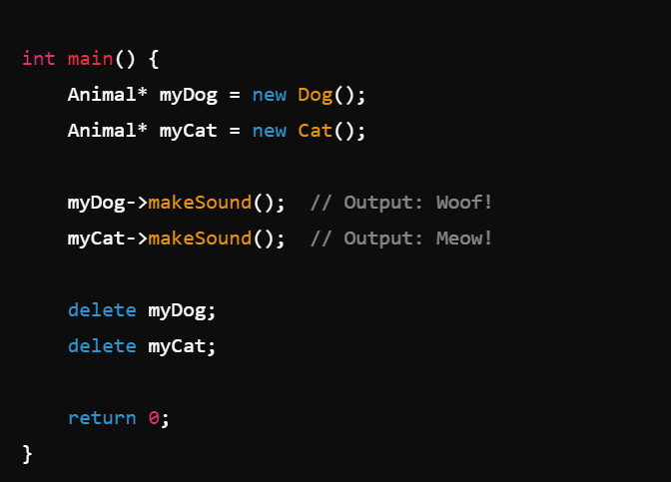

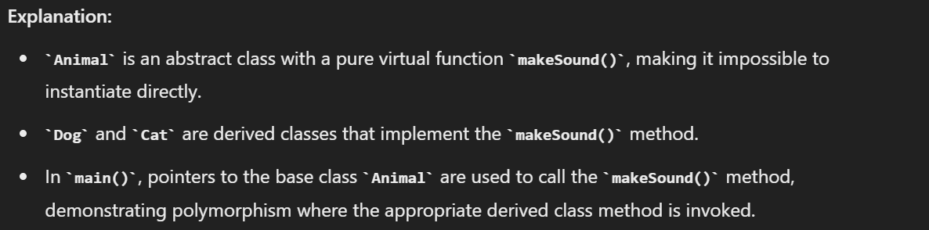
Interface vs. Implementation: Abstraction involves defining an interface (what an object does) while hiding the implementation details (how it does it). For instance, when you use a car, you interact with it through controls like the steering wheel and pedals, but you don’t need to understand the intricate workings of the engine or transmission.
Key points:
Simplified Interface: Hides complex implementation details, exposing only essential features and interfaces.
Improved Code Maintainability: Facilitates changes in the implementation without affecting the code that uses the abstracted interface.
Encapsulation Support: Works hand-in-hand with encapsulation to group related data and methods into cohesive units.
Abstract Classes and Methods: Defines abstract classes with pure virtual functions to establish a common interface for derived classes.
Modular Design: Promotes modularity by defining clear, reusable interfaces and separating concerns.
Inheritance:
Inheritance in object-oriented programming (OOP) is a mechanism that allows one class (the derived class) to acquire properties and behaviors (methods) from another class (the base class). It promotes code reuse and establishes a natural hierarchy between classes.
Key points:
Code reusability: allows you to reuse code from an existing class, reducing redundancy.
Hierarchical Relationships: It creates a hierarchy where a derived class (child) inherits attributes and methods from a base class (parent). This reflects a "is-a" relationship. For example, a Dog is a Animal.
Types of inheritance:
- Single inheritance: A class inherit from a one base class.
- Multiple inheritance: A class inherits from more than one base class.
- Multilevel inheritance: A class inherits from another derived class.
- Hierarchical inheritance: Multiple classes inherit from a single base class.
Access specifiers:
- Public inheritance: Public members of the base class remain public in the derived class.
- Private inheritance: Public and protected members of the base class become private in the derived class.
- Protected inheritance: Public members of the base class become protected in the derived class.
Method overriding:
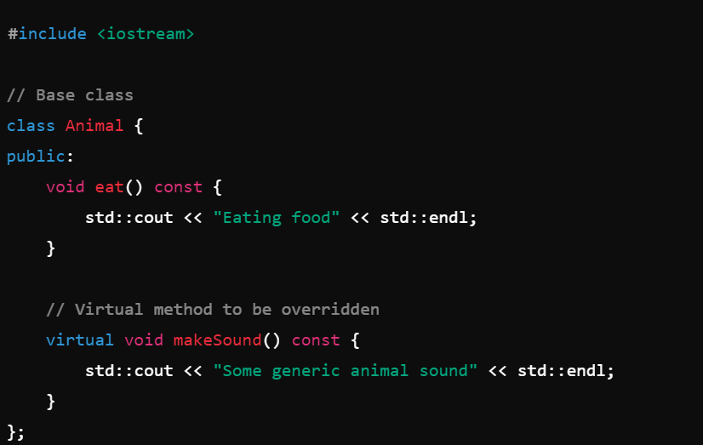

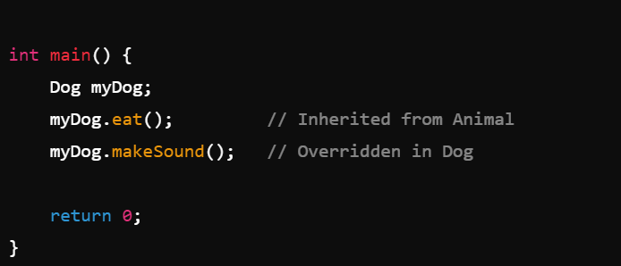
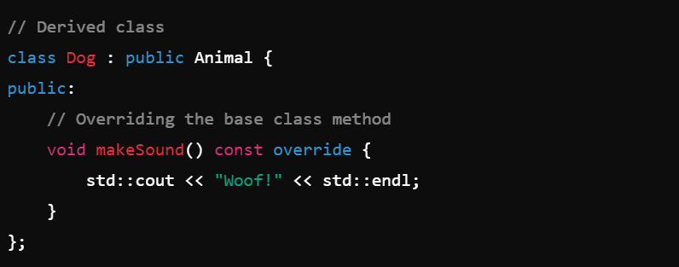

Polymorphism:
It allows objects of different classes to be treated as objects of a common base class, particularly through the use of methods with the same name but different implementations.
Types of polymorphism:
- Compile-time polymorphism (static polymorphism)
- Run-time polymorphism (dynamic polymorphism)
Compile-Time Polymorphism:
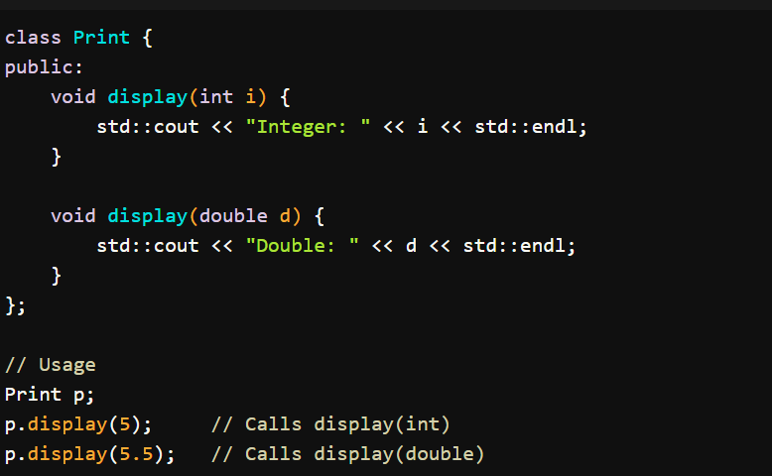
Compile-time polymorphism is achieved through function overloading and operator overloading.

Function Overloading
Function overloading allows you to have multiple functions with the same name but different parameters (different signatures) within the same scope. The function that is called is determined at compile time based on the function signature.

Operator Overloading

Operator overloading allows you to define custom behavior for operators (like +, -, *, etc.) for user-defined classes.
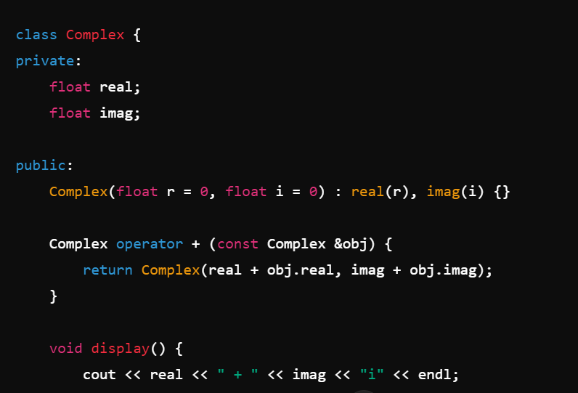
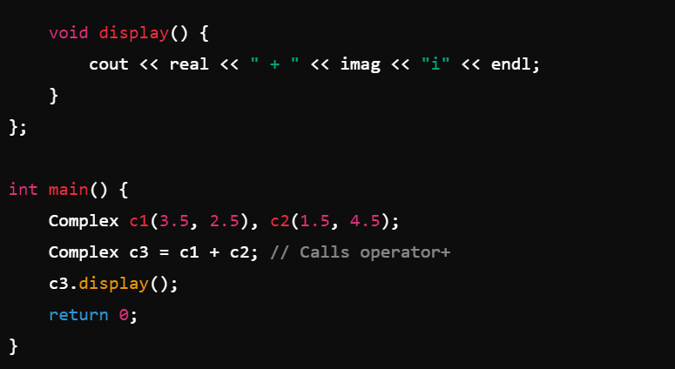

Run-time polymorphism:
Run-time polymorphism is achieved through inheritance and virtual functions. This allows the program to decide which method to call at run-time based on the object’s type.

Virtual Functions
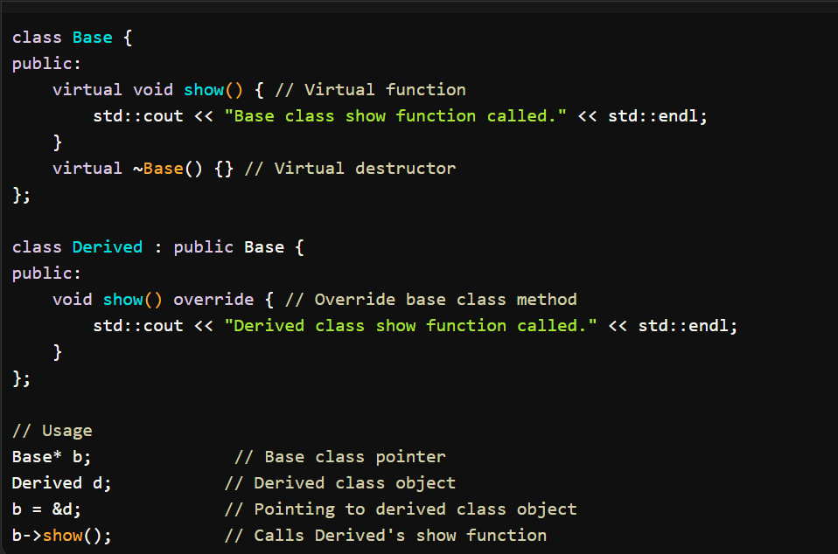
A virtual function is a member function in a base class that you can override in a derived class. The virtual keyword is used to indicate that the function can be overridden.
(Abstract class) Pure Virtual Functions
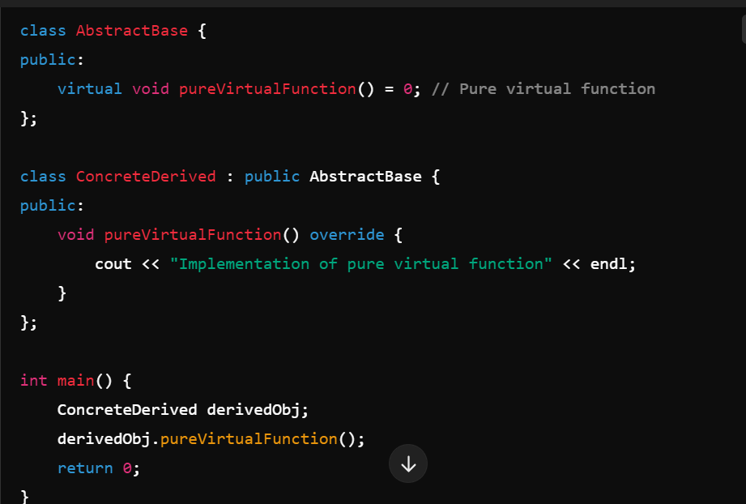
A pure virtual function is a virtual function that is declared by assigning 0 in its declaration. This makes the class abstract, meaning it cannot be instantiated.

AbstractBase has a pure virtual function, making it an abstract class. ConcreteDerived provides an implementation for this function.
Key Points of Polymorphism
Compile-Time Polymorphism: Achieved through function and operator overloading; resolved at compile time.
Run-Time Polymorphism: Enabled by virtual functions and inheritance; method resolution occurs at runtime based on the object type.
Dynamic Binding: Allows functions to be called based on the actual object type, enhancing flexibility.
Abstract Classes: Define interfaces with pure virtual functions, forcing derived classes to implement specific behavior.
Code Reusability: Promotes writing generic code that works across different derived classes.
Maintenance: Simplifies code management and facilitates easier updates and extensions.

What is the difference between data abstraction and encapsulation?
Aspect | Data abstraction | Encapsulation
definition | Hiding complex implementation details and showing only essential features | Bundling data and methods that operate on that data within a single unit class
Focus | Focus on what an object does.(behavior) | Focuses on how the data is protected and accessed
Implementation | Achieved through abstract classes and interfaces | Achieved using access modifiers (private, public, protected) to restric access to class members
Purpose | To reduce complexity and increase efficiency by simplifying the interfaces | To protect the object’s state and ensure data integrity

Exception:
Exceptions provide a way to handle errors and other exceptional conditions that occur during the execution of a program. They help you manage unexpected situations without using error codes and improve the robustness and readability of your code.
Basics of exception:
Throwing exception:
Use the throw keyword to signal that an error or exceptional condition has occurred.
Try catch block:
Use the try block to write code that might throw an exception and catch blocks to handle specific types of exceptions.
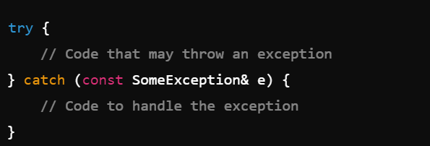
Multiple catch block:
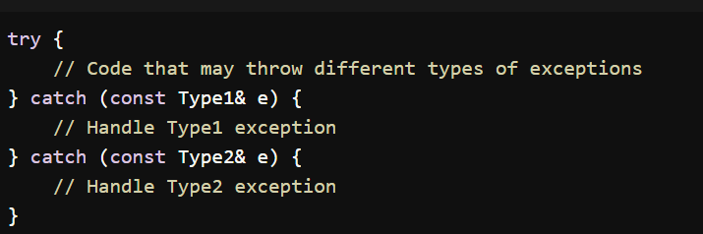
Common Standard Exceptions:
std::exception: Base class for all standard exceptions.
std::runtime_error: Indicates errors that can only be detected during runtime.
std::logic_error: Indicates errors in program logic (e.g., invalid arguments).
std::out_of_range: Indicates an out-of-range access attempt.
std::invalid_argument: Indicates an invalid argument passed to a function.
Custom exception classes:
Defining a custom exception:
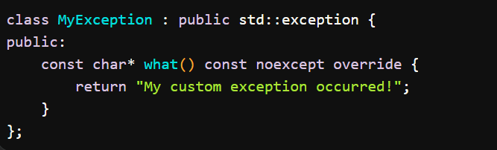
Throwing a custom exception:

Best practices:
Always catch by reference: catch exception by reference to avoid slicing.
Use specific exceptions: catch specific exceptions before more general ones.
Avoid using exceptions for control flow: use exceptions for error handling only, not as a mechanism for controlling program flow.
Example:
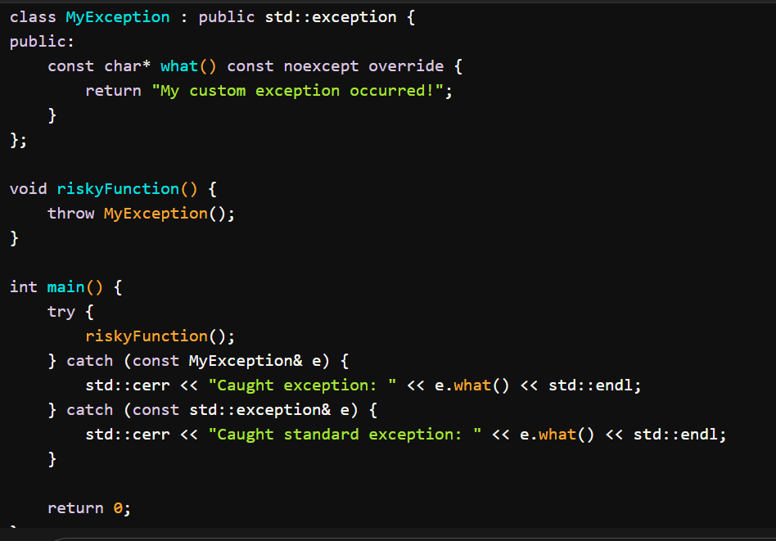

Templates:
Templates are a powerful feature that allows you to write generic and reusable code. They enable you to define functions and classes that can operate with any data type without knowing the exact type in advance. Templates help you achieve type independence and flexibility in your code.
Types of templates:
Function template:
Function templates allow you to create functions that work with any data type. You define a template with a placeholder for the type and then use it for various types.
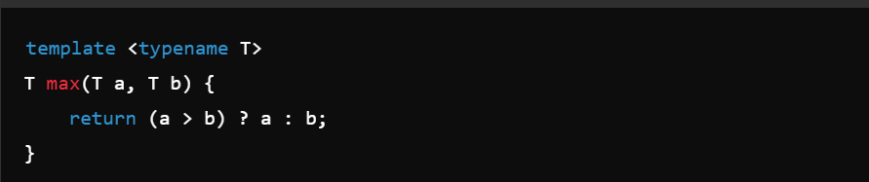
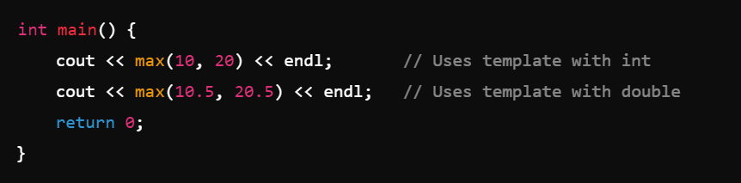
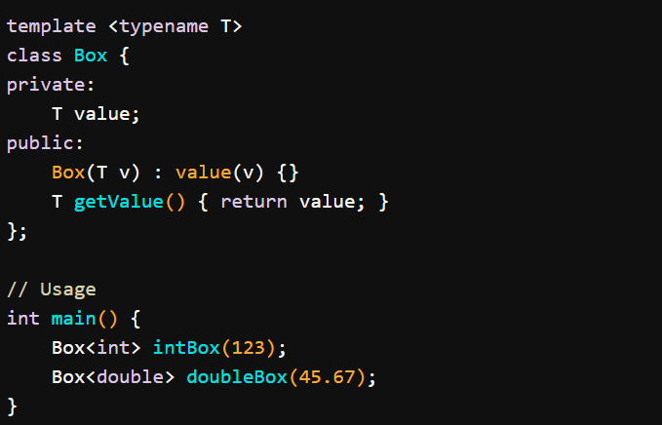
Class templates:
Class templates allow you to create classes that operate with any data type. You define a template with a placeholder for the type and then use it to create instances with different types.

Template specialization:
Full specialization:
Full specialization provides a complete and specific implementation of a template for a particular type or set of types.
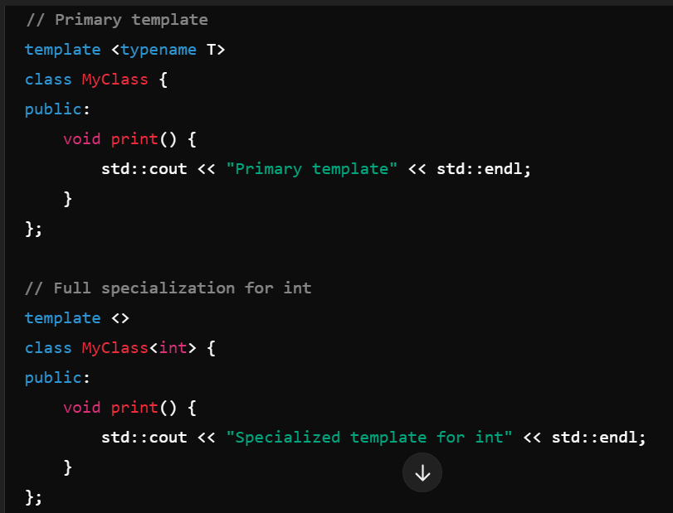
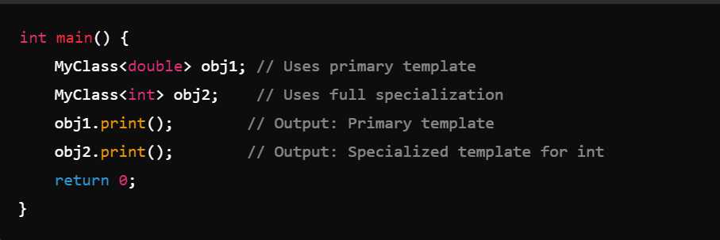

Partial specialization:
Partial specialization allows you to define a template that is specialized for a subset of template parameters while leaving the rest generic. This is useful when you want to specialize the template based on some but not all template parameters.
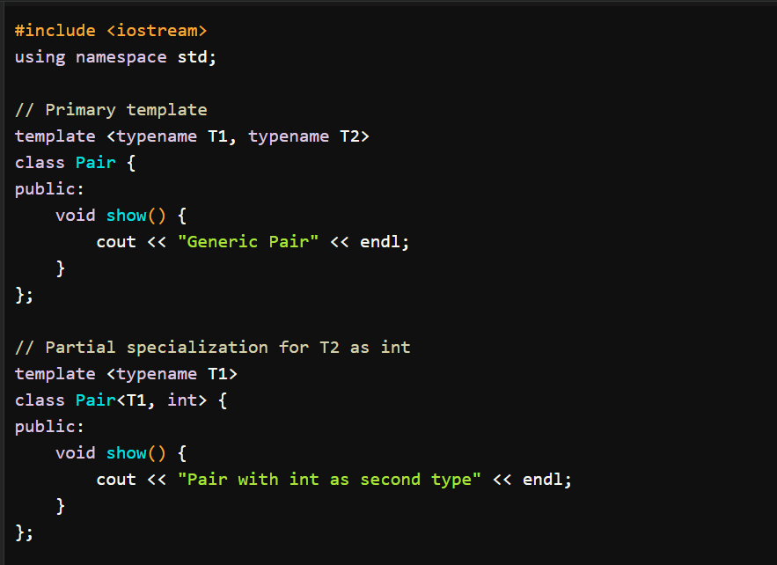
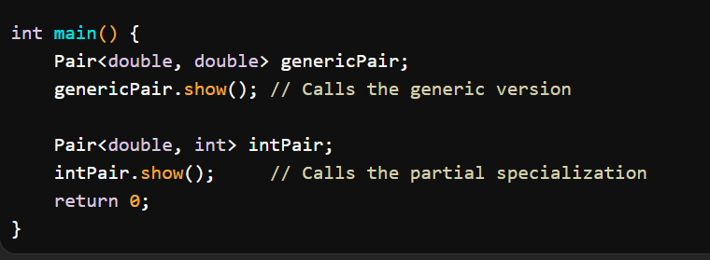
Structures:
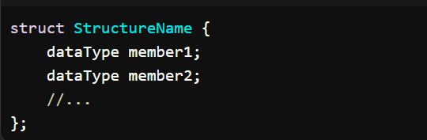
A structure (often abbreviated as struct) is a user-defined data type that groups together variables (members) of different types under a single name. Structures provide a way to encapsulate related data items, making it easier to manage and organize complex data.
Syntax:

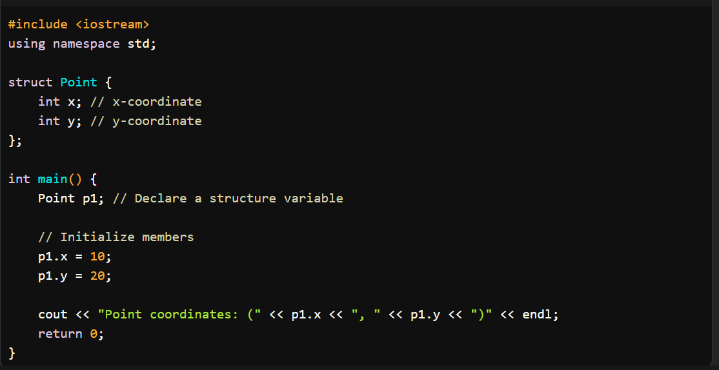
Key features:
Member variables: structures can contain multiple members of different types including other structures, types, pointers, function.
Accessing member: members of struct can be accessed using a dot(.).
Initialization: structures can be initialized using an initializer list.
Arrays of structures: 
Structures and functions:
Structures can be passed to functions as parameters.
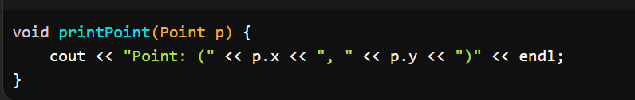
Difference between structures and class?
Aspects | Structures | Class
Default access | Members are public by default | Members are private by default
Default inheritance | Inheritance is public by default | Inheritance is private by default
Use cases | Used for simple data aggregation without much behavior. | Used for complex objects with encapsulation and behavior.
Encapsulation | Less emphasis on encapsulation; default access is public. | Focuses on encapsulation; default access is private.
Compatibility and conventions | Historically used in C for data aggregation. In C++, struct has similar capabilities to class but with default public access. Typically used in simpler or POD (Plain Old Data) structures. | Used more extensively in C++ for object-oriented programming, including inheritance, polymorphism, and encapsulation. Preferred for defining objects with significant behavior or requiring data hiding.
With structs, the inherited members maintain their public accessibility and lack the encapsulation features of classes. This distinction alters the way we perceive and implement inheritance with structs.
When to use structures over classes?
Value vs reference types: | Structs are value types, while classes are reference types. This means that when you pass a struct to a method, a copy of the entire data is passed. In contrast, when you pass a class to a method, a reference to the object is passed. This distinction can impact performance, particularly for small, lightweight objects where copying the value might be more efficient than the overhead associated with passing a reference.
Memory allocation: | Structs are allocated on the stack, while classes are allocated on the heap. Stack allocation is typically faster and more efficient, especially for small and frequently-used objects, compared to heap allocation, which involves additional overhead and potential fragmentation.
Immutability: | sturctures are more suitable to representing immutable data,as they are passed by value rather then reference.

Enum:
An enum (short for "enumeration") in C++ is a user-defined data type comprising a set of named integral constants. It is utilized to define variables that can take on a specific, predefined set of values, thereby enhancing the readability and maintainability of your code.
Default Values: Enumerators start at 0 by default, with each subsequent enumerator incremented by 1.
Scoped Enums: enum class provides better type safety and avoids name conflicts.
Advantages: Enums enhance code readability, maintainability, and type safety.
Enums are especially useful when a variable is limited to a small, predefined set of possible values, such as states, options, or configurations.
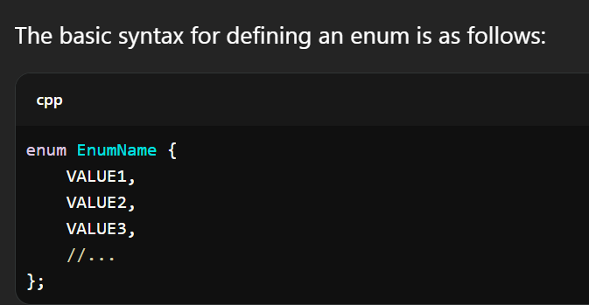
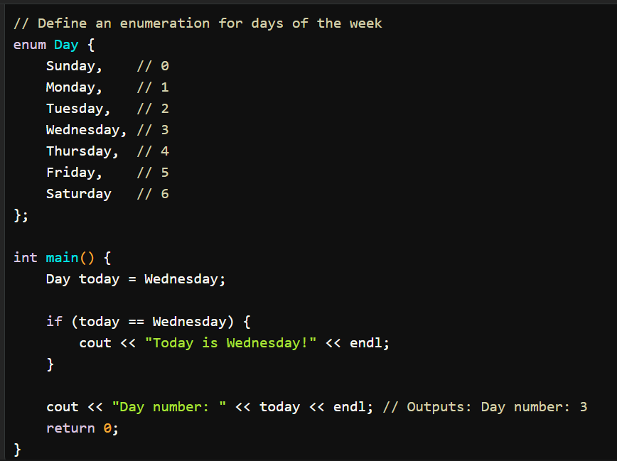
Union:
A union in C++ is a user-defined data type that enables you to store different data types in the same memory location. Unlike a structure, which allocates separate memory for each member, a union uses a single memory block that is shared among all its members. Consequently, a union can hold only one of its non-static data members at any given time.
Key Features of Unions:
Memory Efficiency: Unions are more memory-efficient than structures because they allocate space only for the largest member, sharing a single memory block among all members.
Size of Union: The size of a union is determined by the size of its largest member. This ensures that the union can accommodate the largest data type it holds.
Overwriting Data: When you assign a value to one member of a union, it overwrites the data of other members. Accessing the value of an overwritten member may result in undefined behavior.
Use Cases: Unions are valuable for working with different data types efficiently in memory-constrained environments, such as low-level programming or handling varied data types in protocols.
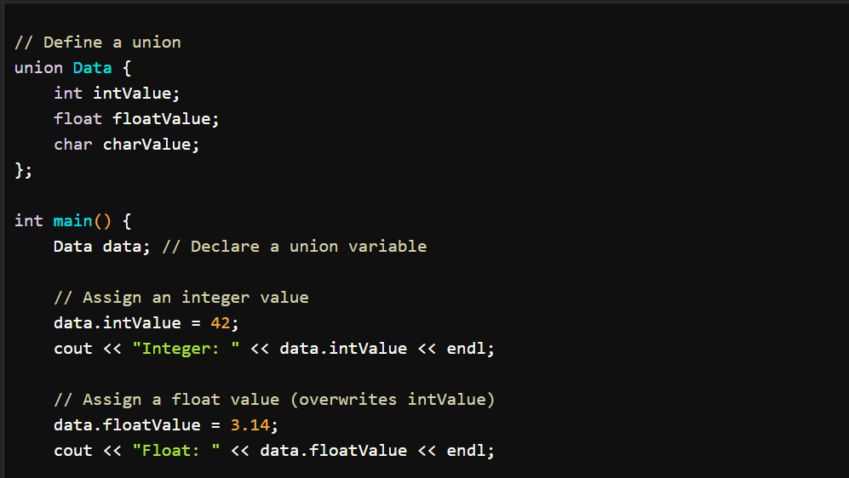
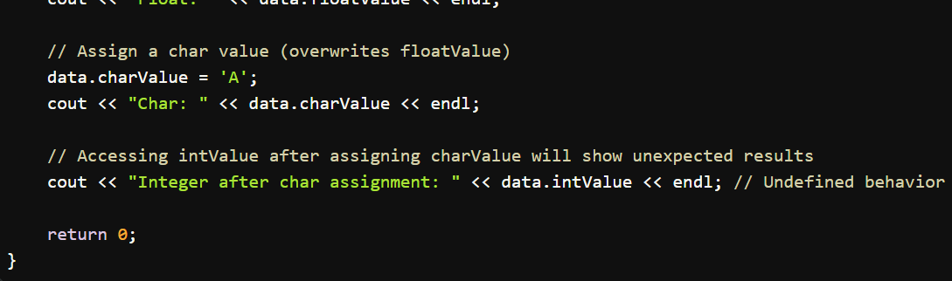

What is Object Oriented Programming?
Object-Oriented Programming(OOPs) is a type of programming that is based on objects rather than just functions and procedures. Individual objects are grouped into classes. OOPs implements real-world entities like inheritance, polymorphism, hiding, etc into programming. It also allows binding data and code together.

Why use OOPs?
- OOPs allows clarity in programming thereby allowing simplicity in solving complex problems
- Code can be reused through inheritance thereby reducing redundancy
- Data and code are bound together by encapsulation
- OOPs allows data hiding, therefore, private data is kept confidential
- Problems can be divided into different parts making it simple to solve
- The concept of polymorphism gives flexibility to the program by allowing the entities to have multiple forms

Can you call the base class method without creating an instance?
Yes, you can call the base class without instantiating it if:
- It is a static method
- The base class is inherited by some other subclass

